Mainframe Workflow Similation(Day 1)
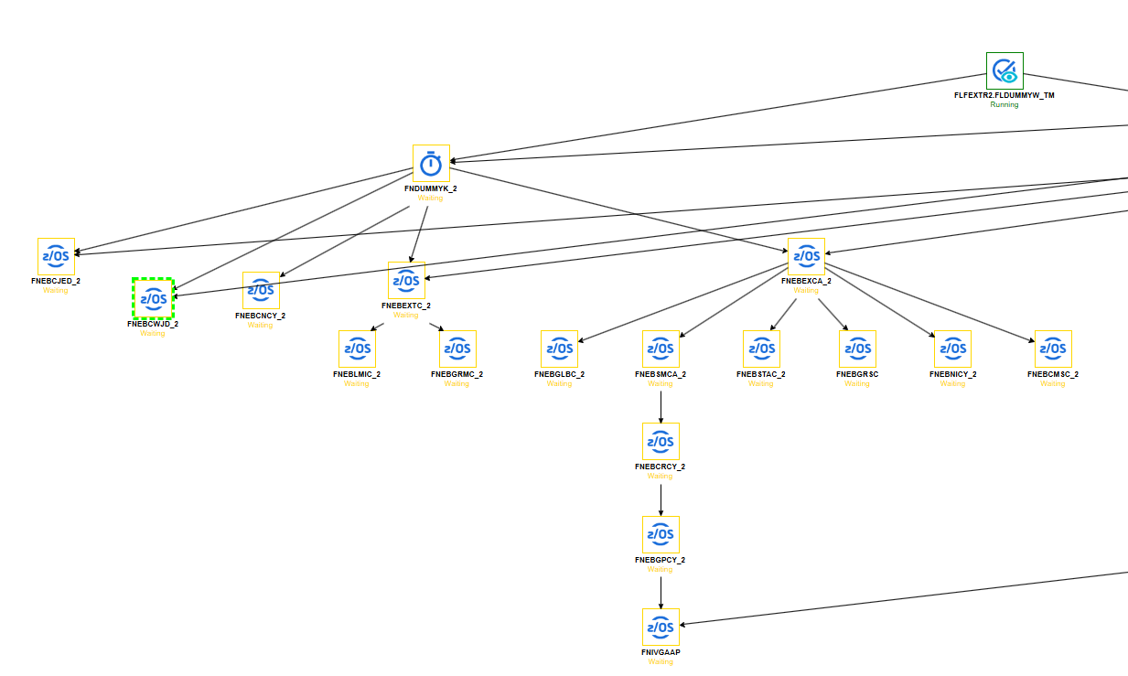

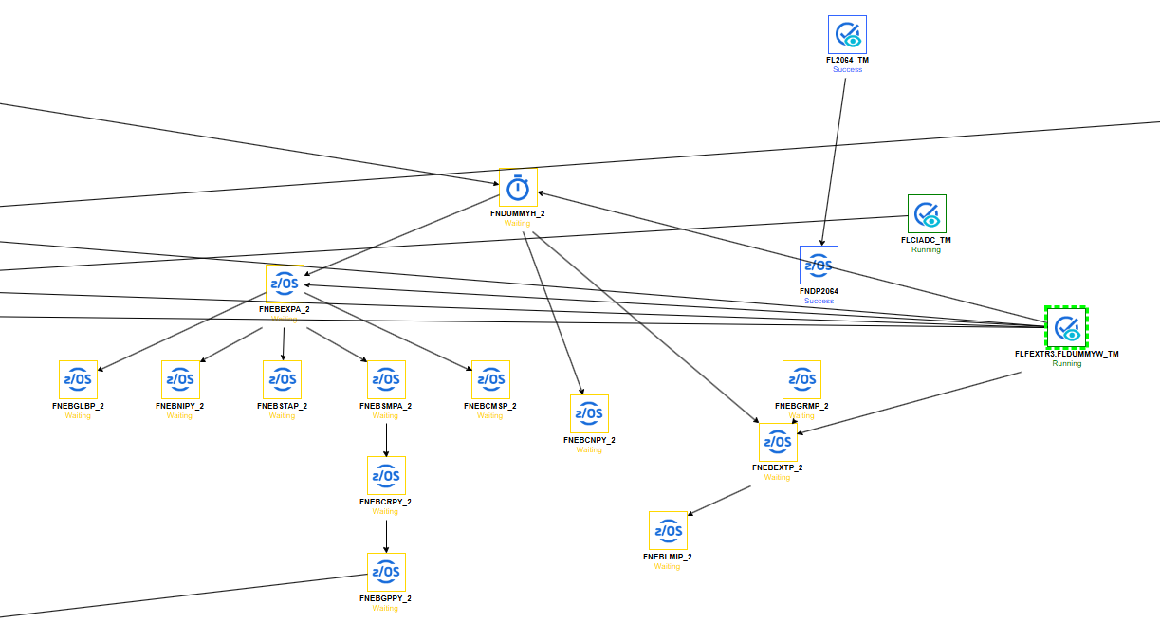

Esssbase Workflow(Lunix Server) Day 1 Similation
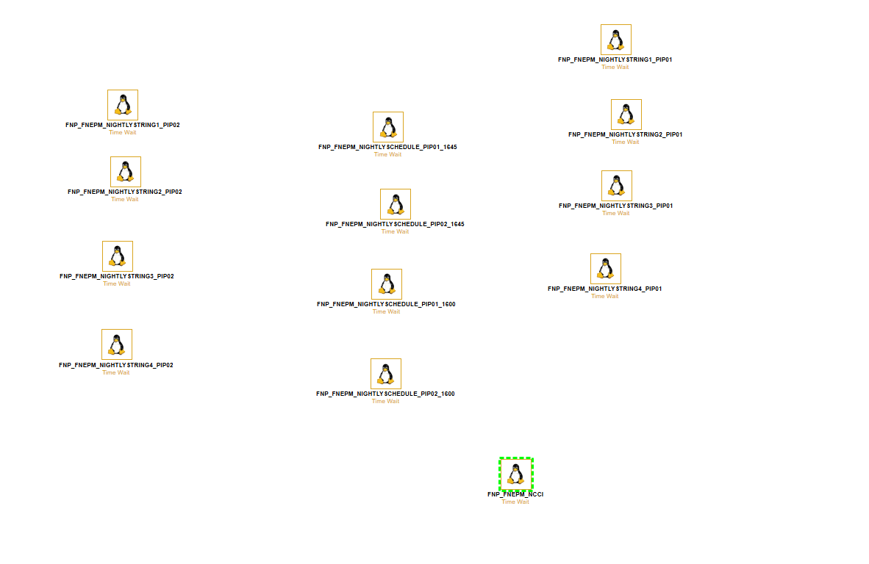

PIP01
PIP02

ESSBASE SERVER (LXPIP-EESSBS01)

Essbase Job
$BIN/NiglFlagPy.sh

Mainframe Jobs
FNEBNIPY
PRODMA.ESP.END.JCLPROD.JOBCARD(FNEBNIPY) à Niglflgp.txt
FNEBNICY
PRODMA.ESP.END.JCLPROD.JOBCARD(FNEBNICY) à Niglflgc.txt

Linux scripts
$BIN/NiglFlagPy.sh
/flags/Nigl/Niglflgp.txt
$BIN/NiglFlag.sh
/flags/Nigl/Niglflgc.txt

Essbase Job
$BIN/CmsubFlagPy.sh
Mainframe Jobs
FNEBCMSP
PRODMA.ESP.END.JCLPROD.JOBCARD(FNEBCMSP) à Cmsflgpy.txt

FNEBCMSC
PRODMA.ESP.END.JCLPROD.JOBCARD(FNEBCMSP) à Cmsflgpy.txt
Linux scripts
$BIN/CmsubFlagPy.sh
/flags/Cmsub/Cmsflgpy.txt
$BIN/CmsubFlag.sh
/flags/Cmsub/Cmsflgcy.txt

Essbase Job
$BIN/SafdacFlag.sh
Mainframe Jobs
FLDACFH1
PRODMA.ESP.END.JCLPROD.JOBCARD(FLDACFH1 à Safdflgcy.txt
**Day 1 script
Linux scripts
$BIN/SafdacFlag.sh
/flags/Safdac/Safdflgcy.txt
$BIN/SafdacCalc.sh

Essbase Job
$BIN/CidacFlag.sh
Mainframe Jobs
FNEBCWJD
PRODMA.ESP.END.JCLPROD.JOBCARD(FNEBCWJD) à Ciadcflg.txt
Linux scripts
$BIN/CidacFlag.sh
/flags/Ciadc/Ciadcflg.txt
$BIN/CiadcCalc.sh
Essbase Job
$BIN/NiayFlag.sh
Mainframe Jobs
FLNIAYFT
PRODMA.ESP.END.JCLPROD.JOBCARD(FLNIAYFT) à Niglflgp.txt
Linux scripts
$BIN/NiglFlagPy.sh
/flags/Niay/Niayflg.txt
$BIN/NiayCalc.sh

Essbase Job
$BIN/GrmusglFlagPy.sh
Mainframe Jobs
FNEBGRMC
PRODMA.ESP.END.JCLPROD.JOBCARD(FNEBGRMC) à Grmflgcy.txt

Linux scripts
$BIN/GrmusglFlag.sh
/flags/Usgl/Grmflgcy.txt
$BIN/GrmusglCalc.sh

Essbase Job
$BIN/CicatFlag.sh
Mainframe Jobs
FNEBCJED
PRODMA.ESP.END.JCLPROD.JOBCARD(FNEBCJEDà Cicatflg.txt
Linux scripts
$BIN/CicatFlag.sh
/flags/Cicat/Cicatflg.txt
$BIN/CicatCalc.sh

Essbase Job
$BIN/CiadcFlag.sh
Mainframe Jobs
FNEBCWJD
PRODMA.ESP.END.JCLPROD.JOBCARD(FNEBCWJD à Ciadcflg.txt

Linux scripts
$BIN/ CiadcFlag.sh
/flags/Ciadc/Ciadcflg.txt
$BIN/CiadcCalc.sh

Essbase Job
$BIN/PmayFlag.sh
Mainframe Jobs
FLPMAYFT
PRODMA.ESP.END.JCLPROD.JOBCARD(FLPMAYFT à Pmayflg.txt

Linux scripts
$$BIN/PmayFlag.sh
/flags/Pmay/Pmayflg.txt

$BIN/PmayCalc.sh

Misc:
These scripts are sending files either from the linux server to the
mainframe ,sending files from the mainframe over to the Linux or from Linux server to the NAS server. Also some of the scripts might be extracting data from a cube to be used by another cube.

$BIN/NiglSAP.sh
$BIN/GrsNi_put.sh
$BIN/GRMPOWERBI5AM.sh

ESSBASE SERVER (LXPIP-EESSBS02)
Essbase Job
$BIN/LmiFlagPy.sh

Mainframe Jobs
FNEBLMIP
PRODMA.ESP.END.JCLPROD.JOBCARD(FNEBLMIP) à Lmiflgpy.txt
FNEBLMIC
PRODMA.ESP.END.JCLPROD.JOBCARD(FNEBLMIC) à Lmiflgcy.txt
Linux scripts
$BIN/LmiFlagPy.sh
/flags/Lmic/Lmiflgpy.txt
$BIN/LmicFlag.sh
/flags/Lmic/Lmiflgcy.txt

Essbase Job
$BIN/LmiFlagPy.sh

Mainframe Jobs
FNEBLMIP
PRODMA.ESP.END.JCLPROD.JOBCARD(FNEBLMIP) à Lmiflgpy.txt
FNEBLMIC
PRODMA.ESP.END.JCLPROD.JOBCARD(FNEBLMIC) à Lmiflgcy.txt

Linux scripts
$BIN/LmiFlagPy.sh
/flags/Lmic/Lmiflgpy.txt
$BIN/LmicFlag.sh
/flags/Lmic/Lmiflgcy.txt

Essbase Job
$BIN/CorpsrFlagPy.sh

Mainframe Jobs
FNEBSTAP
PRODMA.ESP.END.JCLPROD.JOBCARD(FNEBSTAP) à Crflgpy.txt
FNEBSTAC
PRODMA.ESP.END.JCLPROD.JOBCARD(FNEBSTAC) à Crflgcy.txt

Linux scripts
$BIN/ CorpsrFlagPy.sh
/flags/Corpsr /Crflgpy.txt
$BIN/CorpsrCalc.sh
/flags/Corpsr /Crflgcy.txt
Essbase Job
$BIN/CorpcanFlagPy.sh

Mainframe Jobs
FNEBCNPY
PRODMA.ESP.END.JCLPROD.JOBCARD(FNEBCNPY) à Crflgpy.txt
FNEBCNCY
PRODMA.ESP.END.JCLPROD.JOBCARD(FNEBCNCY) à Crflgcy.txt

Linux scripts
$BIN/CorpcanFlagPy.sh
/flags/Corpsr /Crflgpy.txt
$BIN/CorpsrFlag.sh
/flags/Corpsr /Crflgcy.txt
Essbase Job
$BIN/ GlobalspFlagPy.sh

Mainframe Jobs
FNEBGLBP
PRODMA.ESP.END.JCLPROD.JOBCARD(FNEBGLBP) à Crflgpy.txt
FNEBGLBC
PRODMA.ESP.END.JCLPROD.JOBCARD(FNEBGLBC) à Crflgcy.txt

Linux scripts
$BIN/CorpcanFlagPy.sh
/flags/Globalsp/Glblflgp.txt
$BIN/GlobalspCalc.sh
/flags/Globalsp/Glblflgc.txt

Essbase Job
$BIN/LMIReJEDFlag.sh

Mainframe Jobs
FLCRIJFT
PRODMA.ESP.END.JCLPROD.JOBCARD(FLCRIJFT) à Crijflg.txt

Linux scripts
$BIN/ LMIReCalc.sh
/flags/LMIRe/Crijflg.txt
$BIN/LMIReCalc.sh

Essbase Job
$BIN/GaapFlagPy.sh
Essbase Job
$BIN/GaapFlagPy.sh

Mainframe Jobs
FNEBNIPY
PRODMA.ESP.END.JCLPROD.JOBCARD(FNEBNIPY) à Niglflgp.txt
FNEBNICY
PRODMA.ESP.END.JCLPROD.JOBCARD(FNEBNICY) à Niglflgc.txt

Linux scripts
$BIN/GaapFlagPy.sh
/flags/Gaap/Gpflgpy.txt
$BIN/GaapFlag.sh
/flags/Gaap/Gpflgcy.txt

Misc:
These scripts are sending files either from the linux server to the
mainframe ,sending files from the mainframe over to the Linux or from Linux server to the NAS server. Also some of the scripts might be extracting data from a cube to be used by another cube.

$BIN/GlobalspSAP.sh
$BIN/GrsLMIReJED_put.sh
$BIN/LMIRetoCpare.sh
$BIN/EALHISTSOX
$BIN/EALtoSOX
$BIN/GaapExportCalc.sh
/scripts/Soxreport
$BIN/GaapToInvestment.sh

Most Common On-Call Issues
Scenario 1: Cognizant calls about discrepancies between the Nightly Strings and EssbaseSchedule file.
- Compare the Essbase Schedule and the contents in the Nightly strings. Confirm/fix the discrepancies.
Scenario 2: A job has failed
Remedy:
- Look up the job status email in Essbase Notification mailbox of the failed job and try to see if an error message is provided in the email.
- If unable to find the error message in the status email, then you will need to either access the logs via Putty or Bladelogic and look up the most recent log for the affected cube.
- Error Message “Cannot clear data for database [APP NAME] while other users are connected”
- This is due to users running a large retrieval and essentially frozen in the system.
- To fix, follow Start_Stop_Apps steps
- Rerun the calc version of the failed flag job, i.e. LmiFlag.sh (Flag job) and LmiCalc.sh (calc job) or submit multiple jobs via OnDemand script
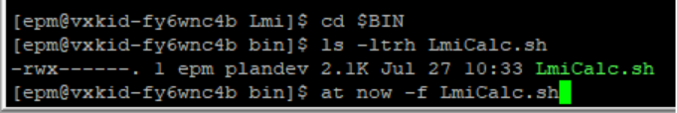

- essmsh error: Not logged in to Essbase
- The job is unable to login to Essbase and could point to a more serious issue on the server. Contact the on call Deployer, and Marty/Will for further investigation.
- Unable to see any error messages or status email does not provide any
- Will need a deployer to login to the server directly and investigate further
- cd into /a/logs directory and look up additional logs
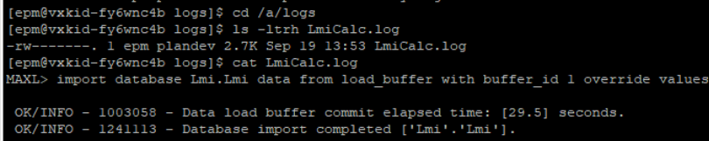
- cd /a/errors/ and change directory into the affected cube name
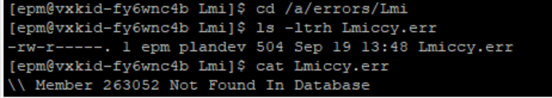
Scenario 3: Jobs are taking significantly longer than normal and still waiting to finish
- Have deployer log you into the affected server
- Cd /a/logs -> ls -ltrh -> ‘cat’ the latest job log available. If the last printed time stamp is longer than 30 minutes, Essbase is mostly likely hung and stuck, and requires Essbase to be restart
- Restart Essbase
- Review logs to determine what jobs have completed successfully and what jobs need to be submitted to run.

Scenario 4: Jobs has not started running yet in a specific Nightly String
- Jobs could be waiting for a flag file in order to run
- cd /flags and change directory into the first job of the affected string and confirm if flag file is there or not
- Confirm if MAINFRAME jobs ran yet in Essbase Notifications i.e. “MF -> FNEB….”(CY) or (PY), if not, there might be an issue with the MAINFRAME side. Contact the Deployer and Georgy/Stan
- Essbase server might be frozen
- Look for the last completed job status email in Essbase notifications and in /a/logs and research the last completed action time stamp.
- Restart Essbase
- Review logs to determine what jobs have completed successfully and what jobs need to be submitted to run.

Resolution Steps:
Restart Essbase
- Submit via Remedy to restart Essbase for the affected server, wait for completion email in Essbase Notifications mailbox
- fnp_fnepm_EssbaseRestart_pip01
- fnp_fnepm_EssbaseRestart_pip02

Stop/Start Application
- Have Deployer login to Essbase Web, Stop and Start the application of the failed job. This will force the user to be logged out and cleared.
- LXPIP-EESSBS01
- LXPIP-EESSBS02
- To Stop application:
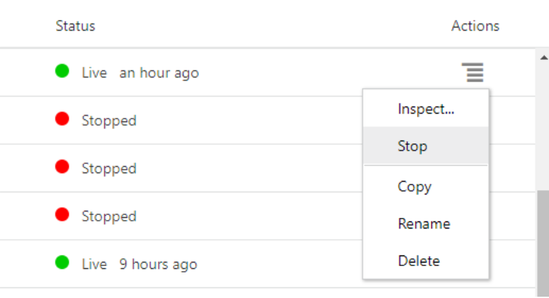
- Start application
